We examined differences in dissolved organic matter quality among seasons (summer, fall, spring) and between reaches (buried, daylighted). HIX, the humification index derived from EEMs, differed by season (GLS, p=0.0005), with autumn having higher HIX than spring or summer, which were not different from each other, and also differed by reach (GLS, p=0.021) with daylighted reaches having higher HIX than buried.

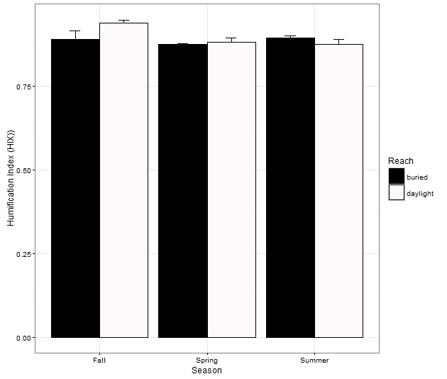

BIX, the biological freshness index derived from EEMs, varied by season (GLS, p<<0.0001) but did not differ between buried and open reaches. Although BIX did not differ between spring and summer, both were significantly higher compared to autumn.

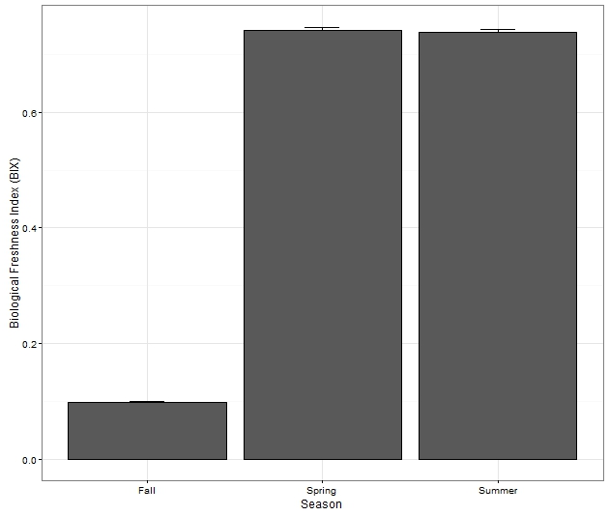

FI, the fluorescence index derived from EEMs, varied by season (GLS, p<<0.0001) but did not differ between buried and open reaches. Although FI did not differ between spring and summer, both were significantly higher compared to autumn.

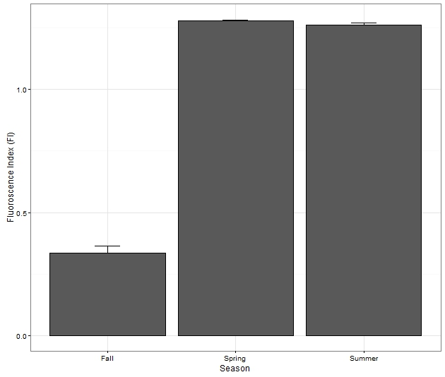

The protein-to-humic ratio uses information from the EEMs to describe the amount of tryptophan-like proteins relative to humic-like compounds, and it is useful for comparisons across seasons and among streams. This ratio varied by season (GLS, p<<0.001), with spring and summer having a higher ratio (more protein) compared to fall, and also by reach (GLS, p<<0.0002) with open reaches having lower ratio (more humic-like) than buried reaches.

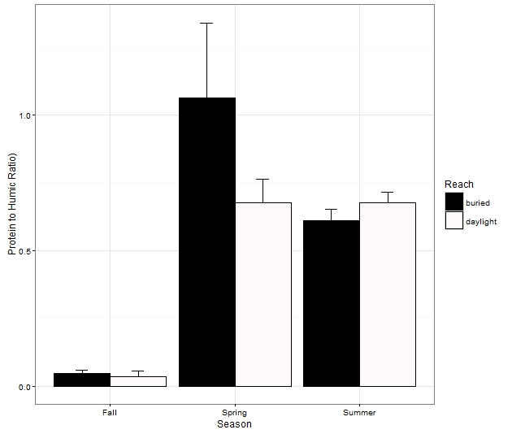

We also deployed ecoenzyme assays to characterize microbial effort to acquire nutrients and use different carbon sources available in the environment. NACE represents effort to acquire inorganic nitrogen from the environment, and we measured highest values in the autumn, intermediate values in summer, and lowest values in spring with all seasons significantly different from each other (GLS, p<<0.0001).

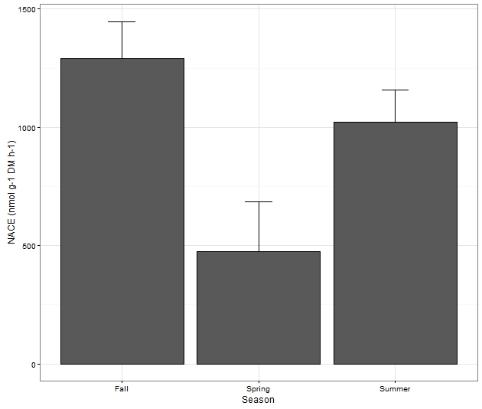

DOPAH2 is an ecoenzyme that correlates to lignin degradation so it is a metric of recalcitrant carbon use. While we found no significant differences in DOPAH2 among seasons, we did find that buried reaches had higher DOPAH2 than open reaches (GLS, p=0.024).

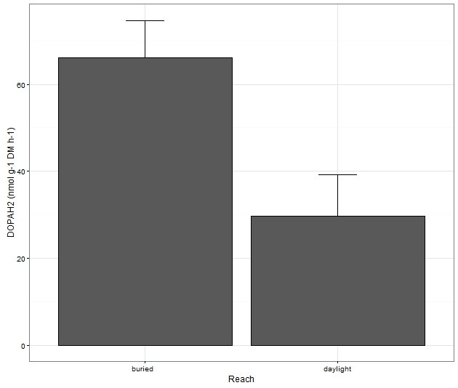

An alternative metric of recalcitrant carbon use, POX, measures polyphenol oxidase activity, and we found higher POX in buried reaches compared to open reaches (GLS, p=0.0043)

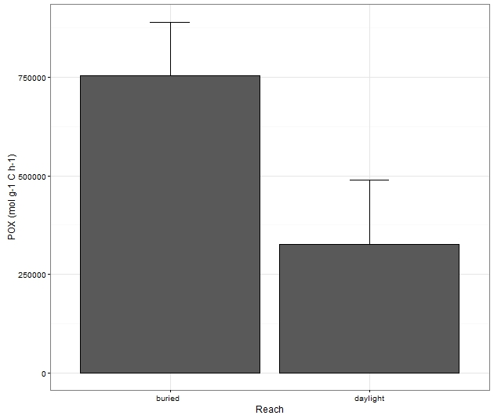

We composited metrics of carbon use together to calculate the LCI, an index of carbon lability that compares recalcitrant carbon use to total carbon use. Therefore, a higher value indicates more recalcitrant carbon use. We found that buried reaches had higher use of recalcitrant carbon (GLS, p=0.014), and we also found that summer had greater use of recalcitrant carbon than autumn(GLS, p=0.027), but there were no differences between spring and autumn.

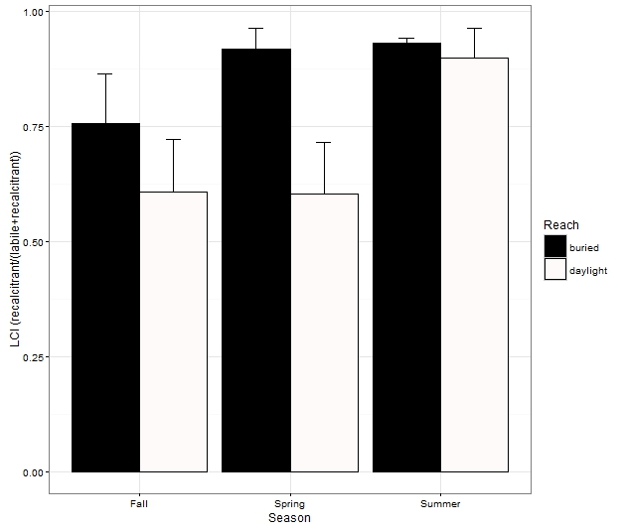

We also deployed NDS amended with different carbon sources (glucose, arabinose, cellobiose, and a no-carbon control) to see if patterns in carbon limitation differed between buried and open stream reaches or between autumn and spring. We focused on autumn and spring to contrast the carbon limitation response to a time when leaf inputs dominate compared to when vernal algae blooms dominate. When respiration on NDS disks was scaled by biomass (g O2 gAFDM-1 h-1), we found no differences among carbon amendments including the no carbon control. However, when the respiration response was scaled by disk area (g O2 m-2 h-1), all NDS carbon amendments were significantly different than the control in all streams, seasons, and reaches (GLS, p>>0.001). Additionally, we found no instances in any NDS deployment where the respiration response differed among the three carbon amendments (GLS, p>0.05). Therefore, we analyzed the nutrient response ratio (NRR) of all carbon types together to detect differences between seasonal and/or reach-scale responses. We found a significant interaction (GLS, p=0.0009) between season (fall versus spring) and reach (buried versus daylight) whereby the respiration response to added carbon was stronger in autumn compared to spring, but daylighted reaches had the strongest response in the fall and buried reaches had strongest response in the spring. (we can probably use just one of these, but both are here for us to evaluate them)

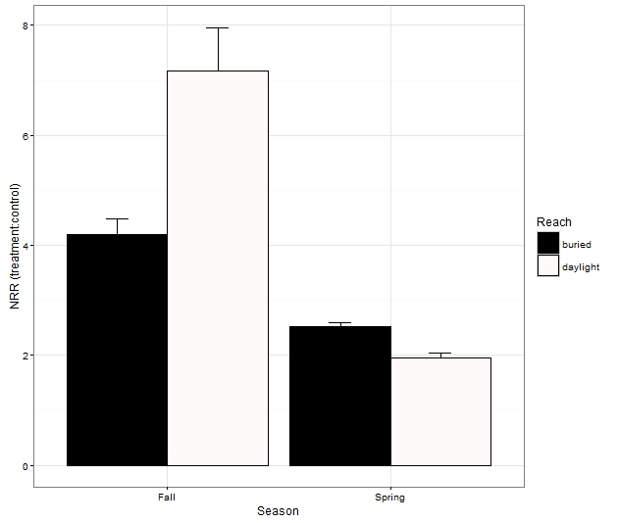

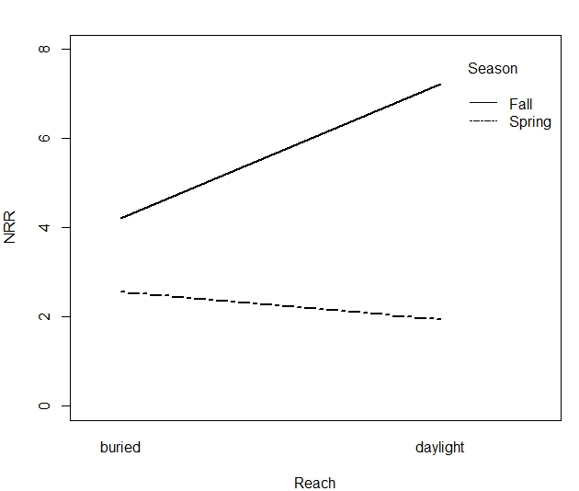

To see what factors might predict the areal NRR response among streams and between seasons and reaches, we analyzed a suite of reach-scale variables including standing stocks (e.g., chl a, periphyton biomass, bacterial cell counts, FBOM, CBOM etc.), water chemistry (e.g., NH4+, NO3-, SRP, DOC, etc.), hydrologic variables (e.g., Q, As/A, travel time, etc.), ecosystem-scale functional attributes (e.g., NO3- uptake, whole-system metabolism), metrics of microbial effort to acquire nutrients using ecoenzyme activity assays, and metrics of dissolved organic matter quality derived from excitation-emission matrices. We found no relationships between the NRR response and water chemistry, hydrology, or ecosystem-scale functional attributes. Although ecoenzyme activities and DOM quality metrics often differed between seasons and reaches, there was no direct relationship between NRR and those metrics. Further, most standing stock metrics were also unrelated to the NRR response, but we did find weak positive relationships between reach-scale standing stocks of CBOM (adonis, p=0.036) and FBOM (adonis, p=0.053).

Table 1. Coefficients from adonis, a permutational multivariate analysis of variance using distance matrices, show weak relationships between nutrient response and particulate carbon standing stocks

|  |  |  |  |  |
| --- | --- | --- | --- | --- |
|  | Glucose NRR | Arabinose NRR | Cellobiose NRR | P value |
| CBOM | 0.072 | 0.060 | 0.064 | 0.036 |
| FBOM | 0.014 | 0.011 | 0.01 | 0.053 |